1. What is Matter?
Look around the classroom. Everything, from the clothes you are wearing to the air you breath is matter. Matter is very important. Matter makes up everything including living things like plants and people. It also makes non-living things such as tables and chairs. Things as big as an elephant or as tiny as a grain of sand on a beach are matter.
Everything is matter and matter comes in three different states: solid, liquid and gas. That means that everything is either a solid, a liquid, or a gas. Each state has properties.
2. What does property mean?
Each state 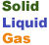has properties, but what does that mean?
A property describes how an object looks, feels, or acts. So that means that liquids look, act, or feel differently than solids or gases.

One property of all matter, whether it's a solid, liquid, or gas, is that it takes up space and has mass.
To help you decide if something is a solid, a liquid or a gas, you need to know the properties, (how it looks, acts or feels) of these three states.

3. What are the properties of a solid?
1. Solids don't change shape easily.
Think of a piece of paper, you can change its shape by crumpling it, but it doesn't change its shape by itself. You have to use your energy to make the shape change.
If you put a solid in a container it won't change its shape... No matter how much you move or slide it around. Think of an ice cube inside a cup. The cube is solid and it stays the same shape.
2. Solid particles don't move around.
3. Solid particles are in an aligned array. Look at the pictures. Notice the circles (particles) are lined up in tight rows. They are so tight they can't move, they just wiggle.

4. What are the properties of liquids?
1. Liquids take the shape of their container.
If you pour milk into a glass it will take the shape of the glass. If you pour the milk into a bowl, it takes the shape of the bowl.
2. Liquids have surface tension. The particles hold on to each other, like holding hands with a friend. The skin or surface of a glass filled with water holds together because the particles hold one to each other. That is called surface tension.
3. Liquids move around. The particles in liquids are farther apart than those of solids, so they can move around more. That's why liquids take the shape of their container.

Sometimes you can change a solid into a liquid. Click on this link to find out how

5. What are the properties of gas?
1. Gas is invisible. That means you can't see it. The particles are so far apart they are invisible, but they are still there! Think about oxygen. You can't see it, but you know it's there because you breath it.
2. Gas particles move around freely. They are spread out move fast, like when you are running on the playground at recess.
Question: What is the gas you inhale (breath in)?
What is the gas you exhale (breath out)?
Sometimes you can turn a liquid into a gas. Click on this link to find out how.

6. Review
Now that you've taken notes about the properties of matter, click on the link below to review what you've learned about solids, liquids and gases.
ReviseWise Matter
7.
Challenge Questions:
1. Think about a can of soda. All three states of matter are there.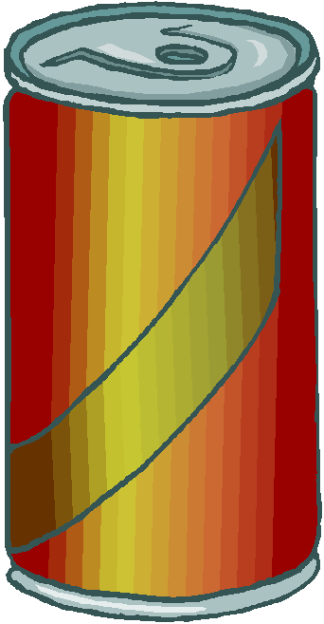
What part is solid matter?
What part is liquid matter?
What part is gas matter?
2. What about you? All three states of matter are a part of you.
Name a part of you that is solid.
Name a part of you that is liquid.
Name a part of you that is gas (hint - think about breathing)
3. A basketball has only two states of matter.
What two states of matter are in a basketball?

